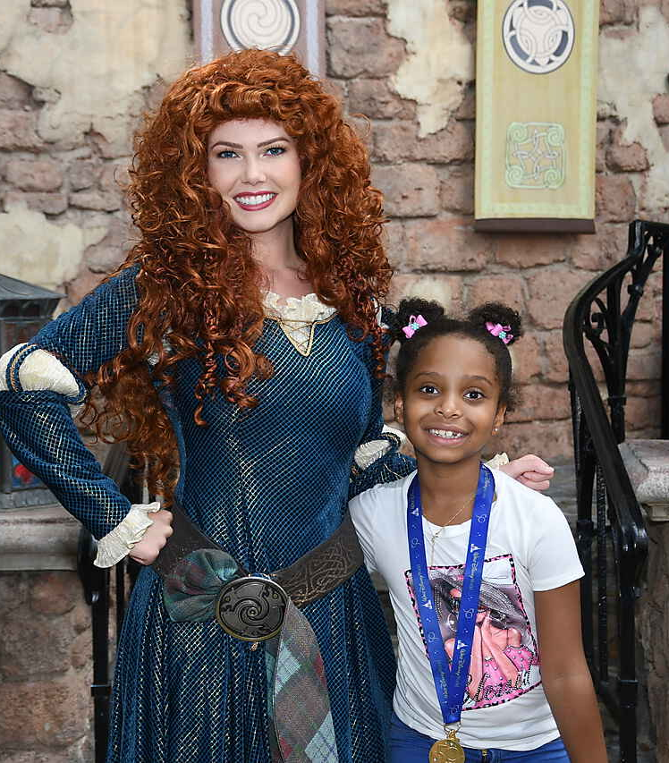
After months of therapy battling stage four Wilm’s tumor, six-year-old Helen wanted nothing more than to go to Disney. When imagining her wish, Helen wanted to meet all her favorite princesses (like Rapunzel), dress up like princesses and hang out with all the characters from her favorite movie Encanto.
Helen counted down the days until the trip arrived. The closer it got, the more she laughed and smiled. Helen’s mother Sonia said it felt heart-warming to see her daughter so excited, and she is so thankful.
“There aren’t words to describe my gratitude. Helen enjoyed her wish so much, 100 thank yous,” Sonia said. “God bless every donor, volunteer, and person who made this possible.”
In September, Helen and her family experienced the magic of Disney, Universal Studios, and SeaWorld. Helen met all her favorite Disney heroes like Goofy, rode the Hogwarts Express on platform 9 and ¾, and will have memories that last a lifetime with her parents and sister!

I wish to go to Florida theme parks!
Helen, 6
Elgin, TX
Wilm's tumor
Meet Helen
I wish to go to Florida Theme Parks!

“Helen will never forget this. She is so happy her dreams came true.” - Sonia, Helen's mom

