“We bonded and are very happy for the opportunity given to our family.” - Monica

I wish to go to Florida Theme Parks
Juan, 6
Rio Bravo
Cystic Fibrosis
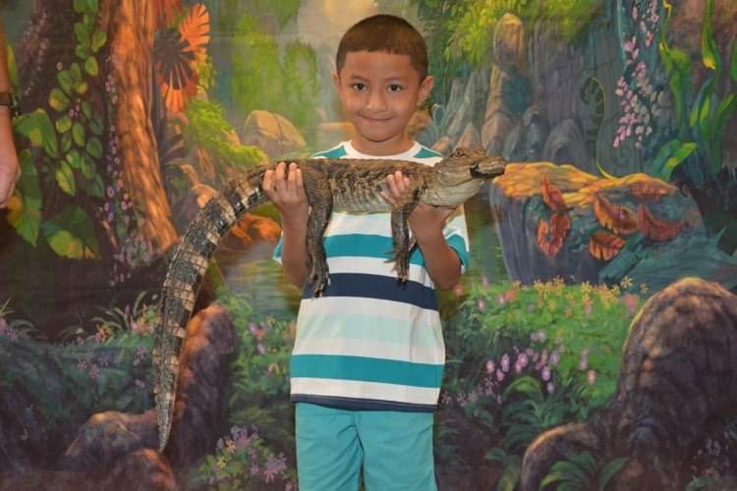
Juan is a thrill-seeking six-year-old with many interests. From riding his scooter outside, to playing Fornite on his PS5, Juan likes to have fun and smile. He has a higher fear tolerance than most as he likes to watch scary TV shows, like You, with his family.
When imagining his wish, Juan knew he wanted to go to Disney to meet his hero Spiderman and other idols like Mickey Mouse. Juan also looked forward to riding roller coasters and seeing the Disney castle and firework show. The most important part of his wish was having a good time with his parents and siblings.
In August, Juan and his family traveled to Florida to experience the full Florida Theme Park Adventure package, experiencing the magic of Disney World, SeaWorld and Universal Studios.
After his wish, Juan’s mother, Monica, said Juan seemed more confident in his emotional and physical strength to fight his cystic fibrosis and is able to express himself more with his family and friends. We are thrilled Juan had an incredible time on this magical trip and the experience made such an impact on his and his family.

I wish to go to Flordia Theme Parks!

Meet Juan

