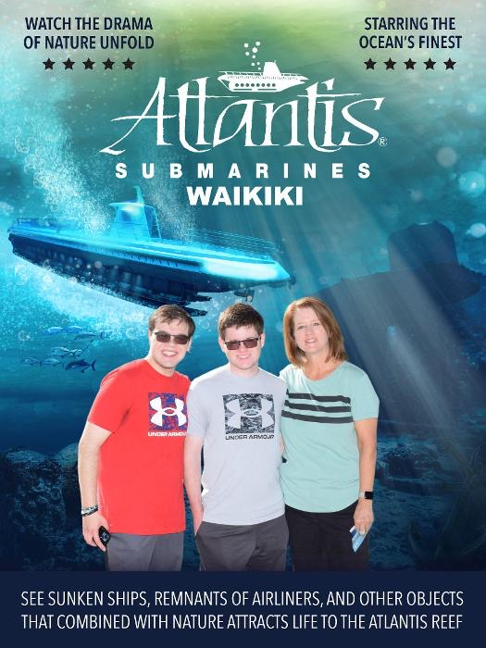

Clay, 18
Austin
Heart and kidney transplant
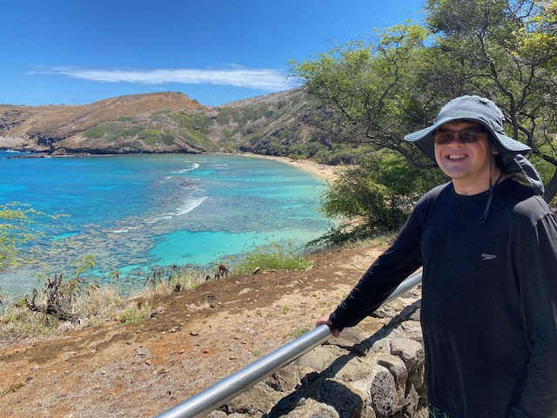
Meet Clay
I wish to go to Hawaii!

Clay loves the outdoors, especially when water is involved. His favorite activities are swimming, boating, and fishing. Clay’s condition, though, made it challenging to enjoy these on a daily basis.

Clay was on dialysis several times a week causing him to lack energy and feel like he was missing out on life. He received a heart transplant in 2019 and couldn’t travel until one year after recovery. When imagining his wish, he wanted an adventure to remember for a lifetime. A place with all his favorite activities and beautiful beaches came to mind: Hawaii.

In August 2022, Clay and his family arrived in Hawaii. They put their bags in their room and immediately headed straight to the beach! Clay’s mom, Jenifer, said when she looked over at Clay, he had the most peaceful, content smile on his face. The family spent the rest of the trip enjoying activities such as snorkeling in Hanauma Bay, a turtle tour, a submarine ride, and laying in the golden sand.

“It truly was the trip of a lifetime! Thank you to Make A Wish for making this happen for us. And thank you for all the wonderful things Make A Wish does for medically needy kids and their families,” Jenifer said. “It is such an important mission and we are truly grateful for our experience.” Clay and his family are incredibly grateful and will cherish this trip forever!

